User Acceptance Testing (UAT)
Date | 30 September 2026
Team ID | SWTID-2026-1669
Project Name | AI WEATHER WISE API
Maximum Marks

Project Overview:
Project Name: AI Weather Wise
Project Description: [Brief Description of the Project]
Project Version: [Version Number]
Testing Period: [Start Date] to [End Date]
Testing Scope:
[List of Weather Features and Functionalities to be Tested]
[List of User Stories or Requirements to be Tested]
Testing Environment:
URL/Location: [Web URL or Application Location]
Credentials (if required): [Username/Password]

Test Cases:

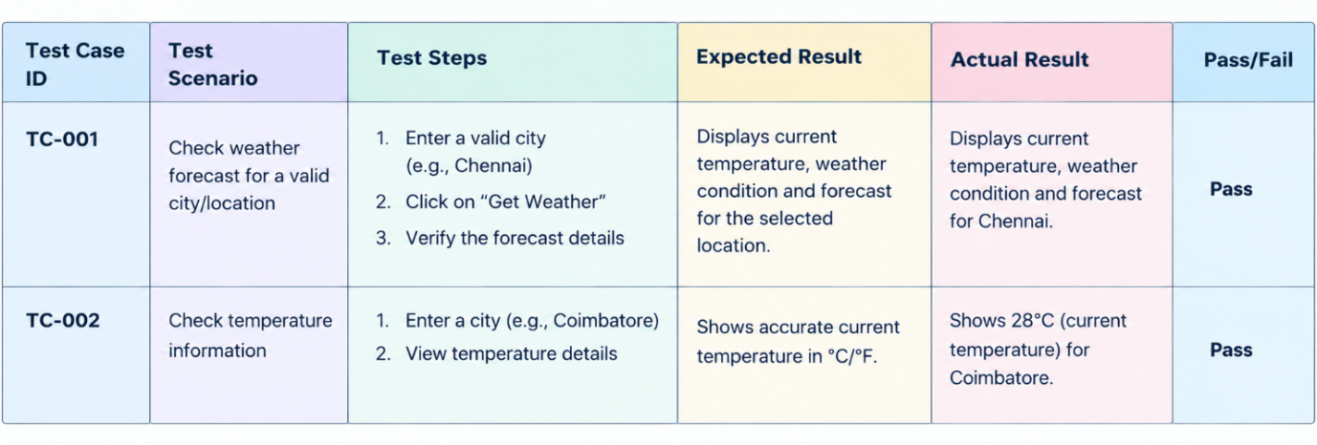

Bug Tracking:

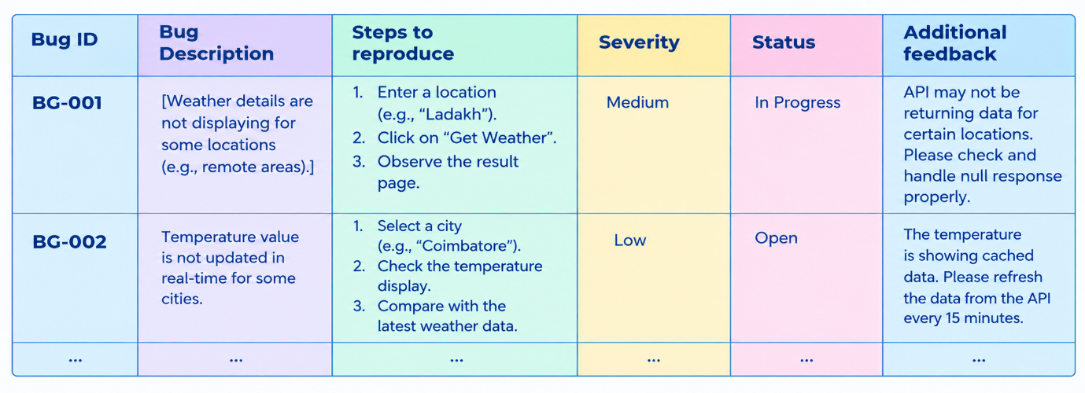

Sign-off:
Tester Name: [Name of Tester]
Date: [Date of Test Completion]
Signature: [Tester's Signature]

Notes:
• Ensure that all AI Weatherwise API test cases cover both positive and negative scenarios.
• Encourage testers to provide detailed feedback, including weather data accuracy and API response suggestions.
• Bug tracking should include details such as severity, status, and steps to reproduce.
• Obtain sign-off from both the project manager and product owner before proceeding with deployment.

